Experiment on Total Dissolved Solids Reduction Efficiency of Water Filters from Five Different Brands at Three Different Districts

Student Number:

*Summary :*

Our experiment wants to examine whether there is significant difference in the filter efficiency among the 5 most popular water filter cartridges, with consideration of possible distinct performance of filters for 3 different water sources. To achieve our aim, we tested TDS value as represent of the filter efficiency for these filters, at three different districts including Bloomsbury, Marylebone and Holloway. To reduce bias and achieve randomisation, we only tested for cold drinkable water for each brand at all three areas and number of trails in each cell was 10 to achieve a balanced design. At the first attempt, two-way ANOVA with interaction and multiple pairwise tests were used to analyse the data. We further improved our experiment by deleting several outliers that considered to have significant influence of our results and did same analysis as before. In general, the difference among five filters and three districts were significant. Brand 1(Aqua) tends to have highest efficiency and Bloomsbury is the district at which that filters perform best well. While there was no significant difference between brand 1(Aqua) and 2(Brita), brand 5(Amazon) and brand 3(Fillterlogic), also efficiency difference between districts 2(Holloway) and 3(Marylebone) were not significant.

*Introduction*

Nowadays, many families tend to improve the water quality by using household water filter cartridges, which can reduce chlorine and organic impurities, absorb lead and copper so that to reduce the limescale in water.

One of the most frequently used indicator of the water quality related to the limescale is the total dissolved solids (TDS) value, which is a measure of the dissolved combined content of all inorganic and organic substances present in a liquid in molecular, ionized or micro-granular (colloidal sol) suspended form and is used as an indication of aesthetic characteristics of drinking water and as an aggregate indicator of the presence of a broad array of chemical contaminants. (from the Wikipedia)

Five most popular water filter cartridges including Aqua Optima, Brita, FillterLogic, Universal Jug Water filt, and Amazon Basics were chosen in this experiment instead of all types of cartridges in market since according to the online and real shops, these five brands were most accessible to the customers. So, our experiment conclusion can provide valuable suggestions to customers.

We hypothesized that the TDS values of the cold drinkable raw water from water taps remain stable in a short period of time – the time interval that necessary for the test of each cartridge in each district so that we can guarantee the precision of the instrument – the TDS electronic test pen for this experiment.

*Design and data*

The response variable of this experiment is the total dissolved solids (TDS) value of the water. According to the product description of these five water filter cartridges, the TDS value of the water should be lower after it being filtered, so it is reasonable to choose the TDS value of the response variable to indicate the efficiency of water filter cartridges.

In order to detect possible confounding variables and reduce bias, we conducted some trial runs and noticed that the temperature and the drinkability of water influenced the TDS value of water so we only use the cold drinkable water as water resource at each district and this will not influence the credibility of our experiment conclusions since drinkable water taps are available in most areas of London and people tend to take drinkable water for daily eating rather than non-drinkable water. Besides, the trail run about the TDS value difference of the raw cold drinkable water at different times showed that the difference is not significant, so we ignored the time factor when we conducted the experiment. However, another trail run showed that the TDS value of cold raw drinkable water varied among these districts—Bloomsbury, Marylebone and Holloway. This may influence the efficiency of filters and cause bias, so the district was chosen as an explanatory variable in supplement of brand variable and considered possible interaction in this experiment.

To achieve randomisation, at each district, every cartridge was tested ten times and each time includes two TDS values: the raw water and filtered water. At each time, the raw water was directly picked from the water-tap and tested and after that, the water was filtered tested. In this way, we achieved a balanced design and ensured that we had same number of observations in each cell. Furthermore, after each time tested, the test pen was cleaned so that the residual water did not influence the following data. While the water filter jug cannot be totally cleaned so every time half jug of water was filtered so that the influence of residual water can be minimised.

*Analysis*

We used boxplots to briefly detect possible difference among brands and districts. The boxplots (Figure 1) showed that the filter efficiency difference existed among five brands filters and Aqua may have the highest efficiency, while different districts also showed different value and Bloomsbury maybe the district at which filters performed best well. Summarised from figure 2, the Aqua seemed to perform best and Universal Jug Water filt was the worst. But according to the interaction plot, different brand had quit distinct trends along districts especially for Fillterlogic, meaning that each brand had different efficiencies at different districts, so it is reasonable to include interaction effect into our model.

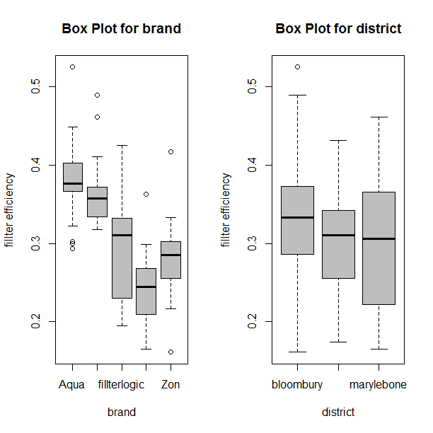

Figure 1: Boxplot for 2 qualitative explanatory variables

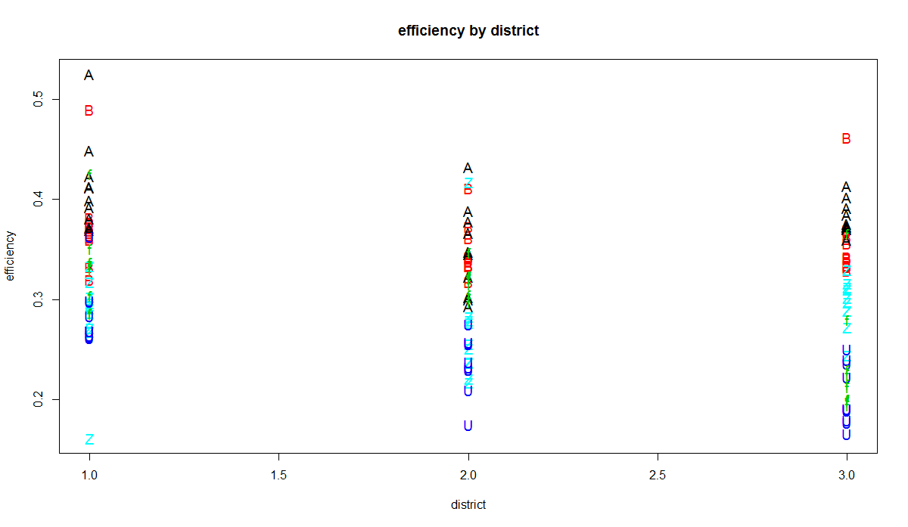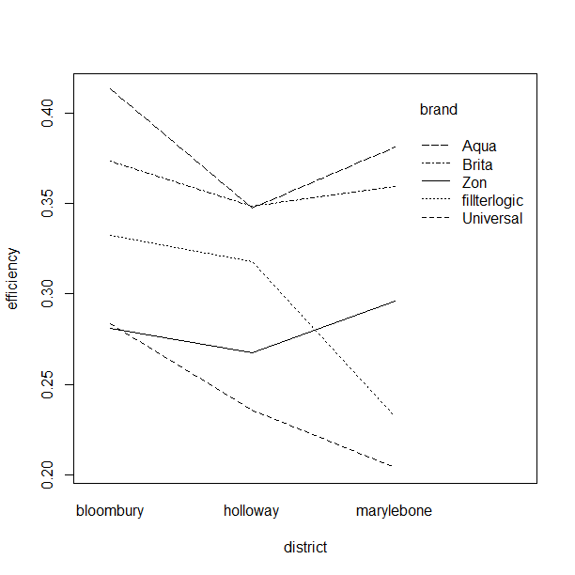

Figure 2: Plots to check interactions

We firstly used two-way ANOVA with interaction to model our data. Based on the ANOVA table (Table 2), water filter cartridge efficiency among the brands, districts and interaction effect were statistically significant. From Table 3, the estimated efficiency for brand1(Aqua) was 0.381 which was the highest and brand4(Universal) had the lowest efficiency of 0.241. Also, the average efficiency at Bloomsbury was significantly higher than Holloway and Marylebone, by 0.033 and 0.042 respectively. All the results verified what we guessed in previous plots.

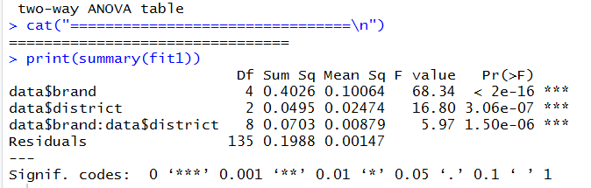

Table 2: ANOVA table

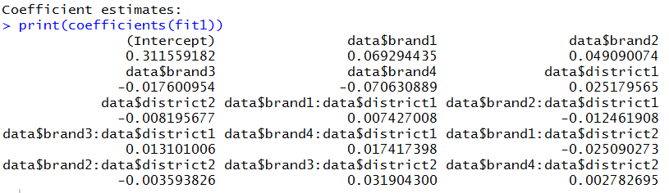

Table 3: Coefficient estimates

To further detect where did the differences among brands and districts arise from, we did multiple pairwise tests (Tukey HSD test). From table 4 and figure 3, it was very interesting to notice that there was no significant difference between Brita and Aqua, Amazon and Fillterlogic at 95% confidence level. The average efficiency of five cartridges did not have significant difference between Marylebone and Holloway.

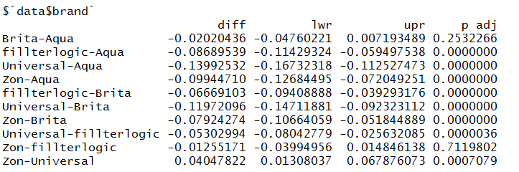

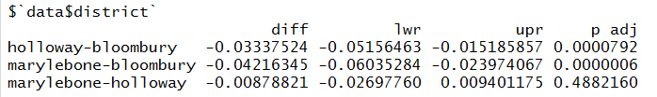

Table 4: Tukey HSD tests

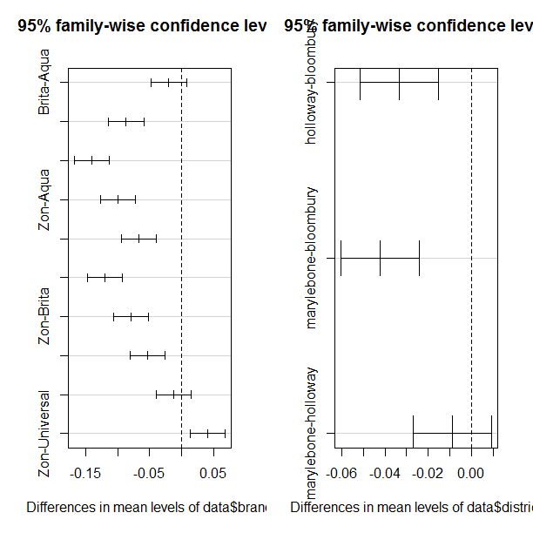

Figure 3: Multiple pairwise tests

In terms of model assumptions, the residuals were scattered randomly among zero and the histogram of residuals remained almost symmetrical so there was no tendency between residuals and fitted value. While for the QQ-plot, residuals were biased up and obvious non-normality was shown in right tails of the residual distribution. So, the model was adequate, but several outliers have largely affected the result. Observing the data, the outliers mainly showed in the first-time data of each cartridge at each district. It is reasonable to assume that the outliers were caused by the variation of the dryness of the filter cartridges the filter efficiency of a totally dry filter cartridge was much higher than the humid one. So, we removed the first-time data of each filter at each district and re-ran the model using same methodology as before.

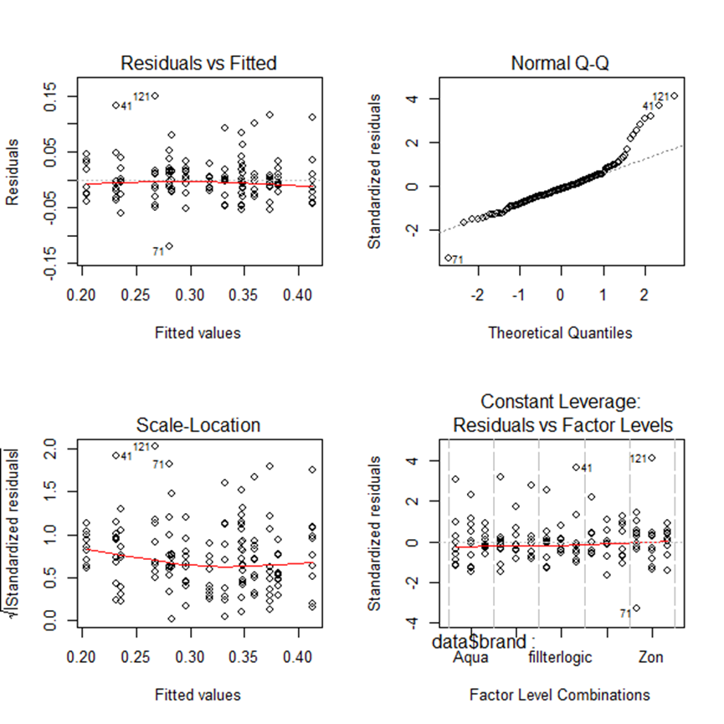

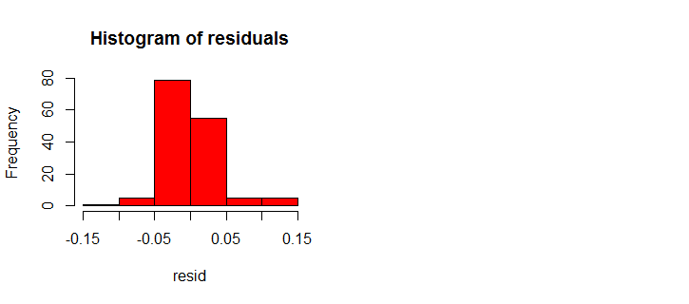

Figure 4: Plots to check model assumptions

After deleting the outliers, the result of two-way ANOVA with interaction model (Table 5) showed that water filter cartridge efficiency among the brands, districts and interaction effect were still statistically significant. The model has been more adequate in terms of the model assumptions. Biased up residuals on the right tail has disappeared and the Q-Q plot was almost a straight line, meaning that the normality assumption of residual distribution was satisfied. Besides, residuals scattered randomly among zero and the histogram of residuals almost remained symmetrical so there was no obvious relationship between residuals and fitted value.

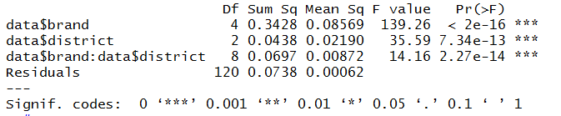

Table 5: ANOVA table

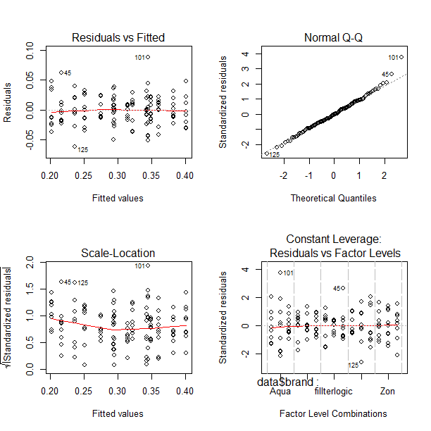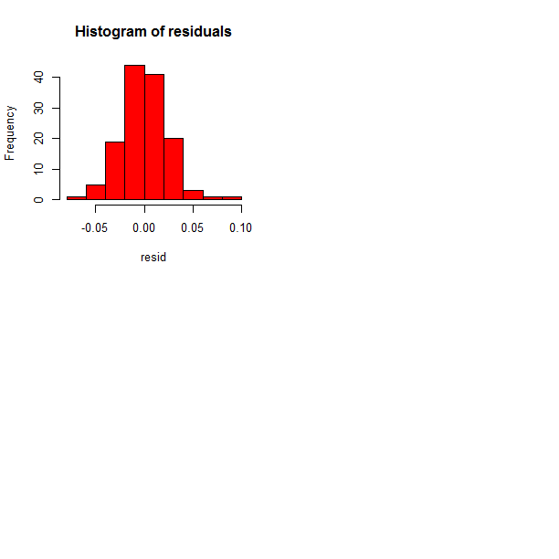

Figure 5: Plots to check model assumptions

According to results of multiple pairwise tests (table 6 and figure6), it is very interesting to notice that the insignificance for difference between Brita and Aqua in previous analysis now became significant, so the outliers had significantly influenced our conclusion for pairwise comparison.

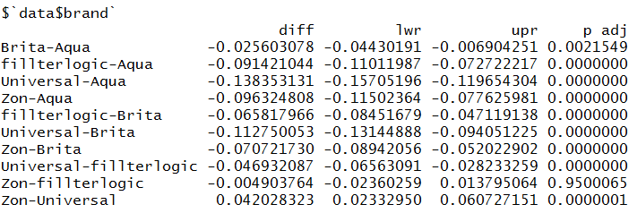

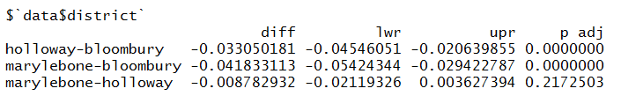

Table 6: Tukey HSD tests

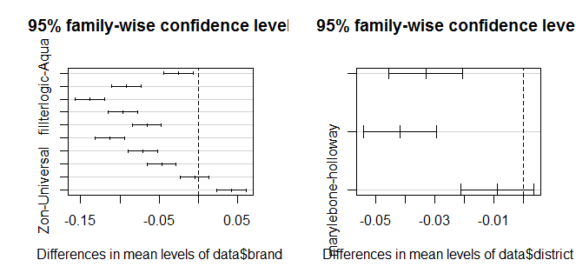

Figure 6: Multiple pairwise tests

*Discussion*

Through our experiment which compared efficiency of water filter cartridges together with district effect, different brands have different efficiency across districts. When considered with price of filters, we can conclude that there is no direct relationship between the price and efficiency of filters. The most expensive one is Universal but performs worst as measured for TDS value, while Fillterlogic is the cheapest one but performed at almost average level of all 5 brands.

To give recommendation for potential filter buyers, if they give priority to efficiency, Aqua is the best one to choose since it has the most efficiency in terms of TDS reduction and is not the most expensive one. When combine price with efficiency, Fillterlogic is the best to recommend because it is the cheapest one but has an average efficiency. It also worse noticing by cumstomers that water source causes significant variation in efficiency of filters so some selling advertisements or promised quanlity guranteed by productors is not highly convincible.

There are many other aspects need to be considered when evaluating a filter cartridge except for the TDS test performance, like compatibility, duration, material and so on and the conclusions of this experiment can only provide some references when comparing and choosing among different filters.